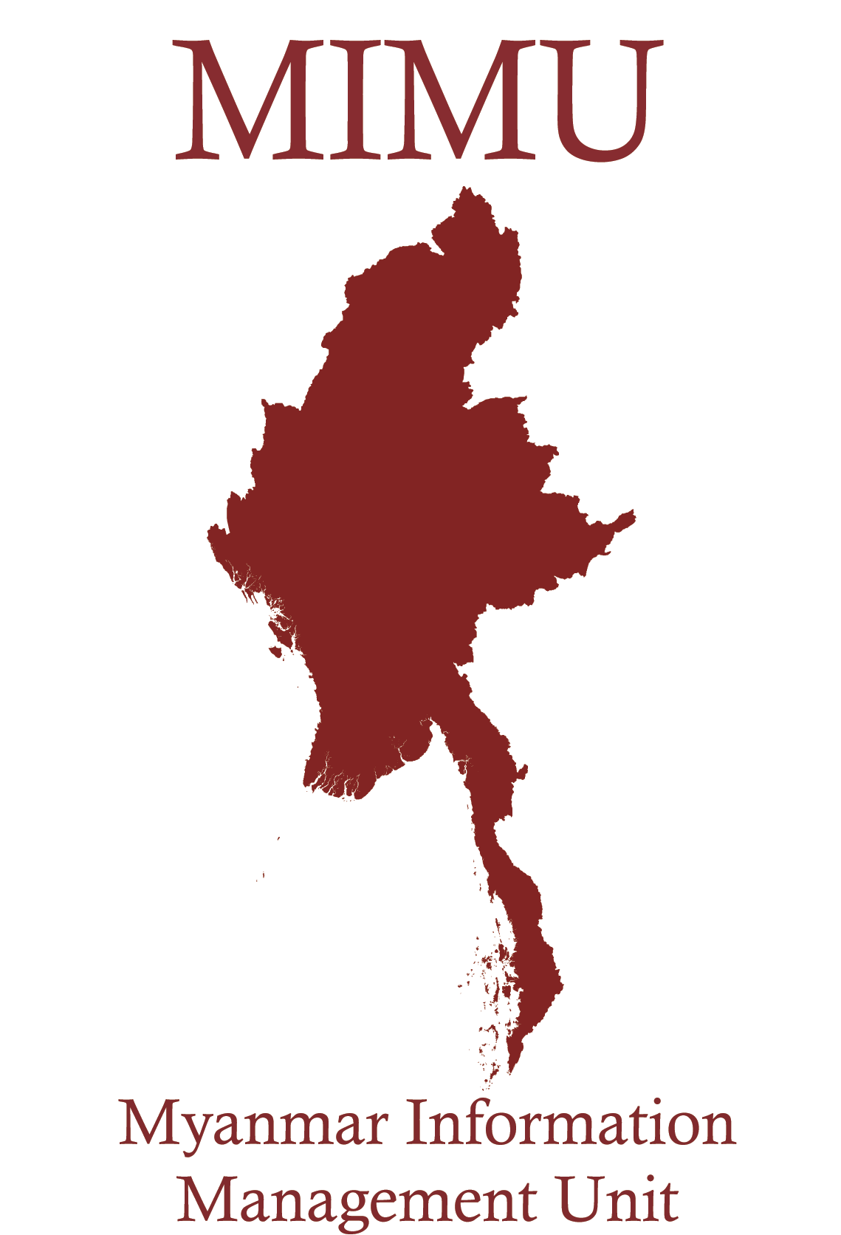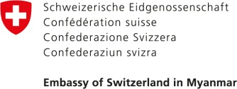

**Myanmar Administrative Structure**

**Union Territory (Naypyitaw) and 14* States & Regions**

**Districts (70)**

**URBAN**

**Townships (330)**

**RURAL**

**Sub-Townships (84)**

**City or Town (398)**

**Wards (3063)**

**Village Tracts (13618) (14220(14220)\*\*\***

**Villages (66,777)\*\***

For Information Management Purposes the MIMU promotes 3 levels for data collection and reporting

Admin 1-First sub-national level (Union Territory and States/Regions)

Admin 3-Third sub-national level (Townships)

Admin 4-Fourth sub-national level (Wards and Village Tracts)

**Source: General Administration Department, Ministry of Home Affairs, 2012**

*There are only 14 States and Regions however; Shan States is subdivided into 3 Sub-States; Bago Region is subdivided into 2 sub-regions.

**This number in the MIMU Pcode list release VI, which also includes settlements as reported by UN and NGOs field offices are differs from the GAD list.

***This P-code was updated on March 2013.***